**PROGRAMS**

**1. Sample Hello world.**

**class Simple**

**{**

**public static void main(String args[])**

**{**

**System.out.println("Hello World");**

**}**

**}**

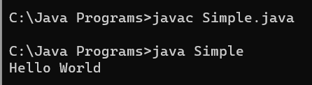

**2. Write a program to add two numbers. Accept numbers using command line arguments.**

**public class Command**

**{**

**public static void main(String[] args) {**

**int a = Integer.parseInt(args[0]);**

**int b = Integer.parseInt(args[1]);**

**int sum = a + b;**

**System.out.println("Sum is " + sum);**

**}**

**}**

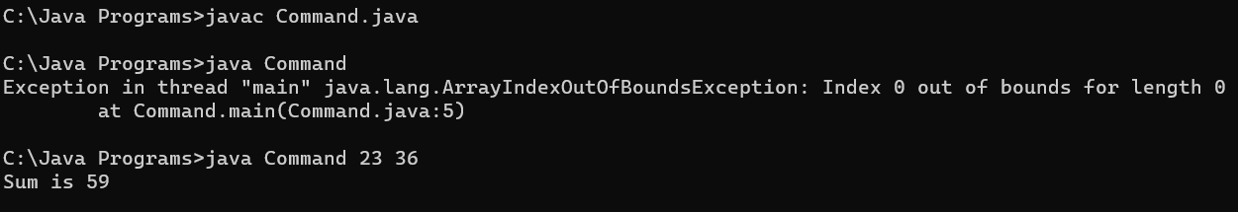

**3. Write a program to**

**a) add two integer numbers**

**class SumTwo**

**{**

**public static void main(String args[])**

**{**

**int x = 5;**

**int y = 6;**

**int sum = x + y;**

**System.out.println(sum);**

**}**

**}**

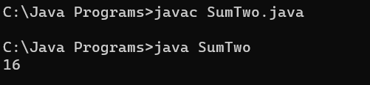

**b) add one float number and one integer number**

**import java.util.Scanner;**

**class AddFloatAndInteger {**

**public static void main(String[] args) {**

**Scanner sc = new Scanner(System.in);**

**System.out.print("Enter a float number: ");**

**float floatNumber = sc.nextFloat();**

**System.out.print("Enter an integer number: ");**

**int integerNumber = sc.nextInt();**

**float result = floatNumber + integerNumber;**

**System.out.println("The sum of " + floatNumber + " and " + integerNumber + " is: " + result);**

**}**

**}**

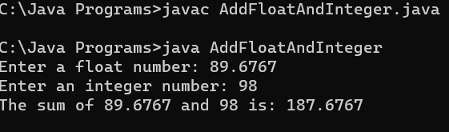

**c) print your name and age**

**import java.util.Scanner;**

**class NameAndAge {**

**public static void main(String[] args) {**

**Scanner sc = new Scanner(System.in);**

**System.out.print("Enter your name: ");**

**String name = sc.nextLine();**

**System.out.print("Enter your age: ");**

**int age = sc.nextInt();**

**System.out.println("Your name is: " + name);**

**System.out.println("Your age is: " + age);**

**}**

**}**

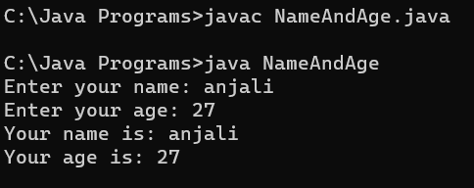

**d) calculate area of Triangle**

**import java.util.Scanner;**

**class TriangleArea {**

**public static void main(String[] args) {**

**Scanner sc = new Scanner(System.in);**

**System.out.print("Enter the base of the triangle: ");**

**double base = sc.nextDouble();**

**System.out.print("Enter the height of the triangle: ");**

**double height = sc.nextDouble();**

**double area = 0.5 * base * height;**

**System.out.println("The area of the triangle is: " + area);**

**}}**

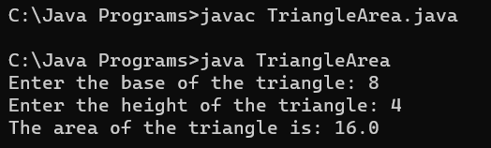

**4. Write a program to swap two numbers with temporary variable. Print the numbers before and after swap.**

**import java.util.Scanner;**

**class SwapNumbers {**

**public static void main(String[] args) {**

**Scanner sc = new Scanner(System.in);**

**System.out.print("Enter the first number: ");**

**int num1 = sc.nextInt();**

**System.out.print("Enter the second number: ");**

**int num2 = sc.nextInt();**

**System.out.println("Before swapping:");**

**System.out.println("First number: " + num1);**

**System.out.println("Second number: " + num2);**

**int temp = num1;**

**num1 = num2;**

**num2 = temp;**

**System.out.println("\nAfter swapping:");**

**System.out.println("First number: " + num1);**

**System.out.println("Second number: " + num2);**

**}}**

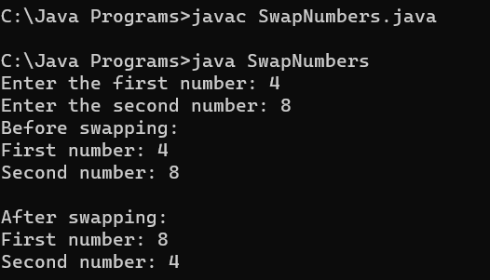

**5. Write a program to swap two numbers „without‟ temporary variable. Print the numbers before and after swap.**

**import java.util.Scanner;**

**class SwapNumbersWithoutTemp {**

**public static void main(String[] args) {**

**Scanner sc = new Scanner(System.in);**

**System.out.print("Enter the first number: ");**

**int num1 = sc.nextInt();**

**System.out.print("Enter the second number: ");**

**int num2 = sc.nextInt();**

**System.out.println("Before swapping:");**

**System.out.println("First number: " + num1);**

**System.out.println("Second number: " + num2);**

**num1 = num1 + num2;**

**num2 = num1 - num2;**

**num1 = num1 - num2;**

**System.out.println("\nAfter swapping:");**

**System.out.println("First number: " + num1);**

**System.out.println("Second number: " + num2);**

**}}**

